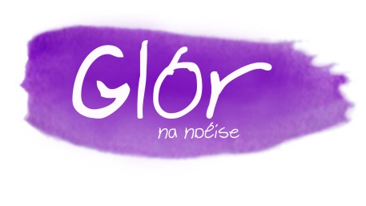
Foirm Iarratais
Campa Samhraidh Gaeilge 2019
Ó Luain an 01/07/2019 go dtí Aoine an 05/07/2019 ó 9.00r.n. go 2.00i.n. gach lá.
(Starting on Monday 01/07/2019 until Friday 05/07/2019, from 9.00 a.m. until 2.00 p.m. each day)

Ainm an Pháiste (Child’s Name): _________________________________________________________
Aois (Age): _____
Tuismitheoirí / Caomhnóirí :__________________________________________________________
(Parents/Guardians)
Teileafón: ______________________________ Fón Póca:___________________________
(Telephone) (Mobile)
E-phost :_______________________________ Dáta Breithe:________________________
(Email) (Date of Birth)
Scoil:__________________________________ Rang Faoi Láthair: ____________________
(School) (Class at present)

An bhfuil aon fhadhb sláinte aige/aici ? (Is there health problems that we should know about?)
______________________________________________________________________________________________________________________________________________________________________________________________________________________________________________________
Cén leibhéal Gaeilge atá aige/aici? (How would you rate their level of Irish)
Íseal Meánach Go Maith
Tabhair faoi deara, le do thoil, go gcaithfidh gach páiste a lón agus sóláistí féin a thabhairt leo gach lá. Moltar bia sláintiúil a thabhairt leo. (Please note that each child must bring his/her own food and drink for the duration of the summer camp, and a sensible, home-made, packed-lunch, etc, is recommended)

Beidh GLÓR NA NDÉISE ar siúl ag an seoladh thíos:
(Glór na nDéise will take place at the following address)

Gaelcholáiste Phort Láirge,
Cúirt an Easpaig,
Baile Gunnair,
Port Láirge.

Seol an fhoirm líonta seo agus éarlais do €30 iníochta le Gaelcholáiste Phort Láirge chuig;
(Please return the completed form, with a deposit of €30 made payable to Gaelcholáiste Phort Láirge, to)

Glór na nDéise
Gaelcholáiste Phort Láirge
Cúirt an Easpaig
Baile Gunnair
Port Láirge
Fón: 051-821742

Tá €35 le híoc ar an gcéad lá den chúrsa (The balance of €35 must be paid on the first day of the Camp)

Is é spriocdháta na bhfoirm iarratais ná 14/06/2019.
The deadline for applications forms is the 14/05/2019.

Síniú/ (signed) ___________________________________________________ (Tuismitheoir/ Caomhnóir)
(Parent/ Guardian)
Ní úsáidfear aon sonraí tugtha anseo d’aon chúis eile ach amháin chun teagmháil a dhéanamh leat i dtaobh an champa nó más gá teagmháil a dhéanamh leat, nó duine ainmnithe agat, faoi do pháiste, más gá, le linn dó/dí a bheith ag freastal ar an gcampa.
The personal information gathered from you here will solely be used for the purpose of contacting you in relation to the camp or for contacting you, or a person named by you, regarding your child , if necessary, while he/she attends the camp.

